**FE5209 Financial Econometrics Group Project Report**

Group:Alpha   
Name: HO Ngok Chao, HU Mingyue, Feng Tiantian, ZHU Haolin, SU Yulu

**Introduction**

Our project is about active investment strategies. The existing literature analyzed the performance of various strategies in old and small datasets. Therefore, our group tested the performance of those strategies in newer and larger datasets and compare their performance with or without transaction cost.

For the fact that there is no strategies backtesting platform for R like Quantopian for Python, we collected data from Bloomberg, implemented strategies in R and tested them using below mentioned strategies.

Codes and data are presented in <https://gitlab.com/johnho/rmr>.

**Methodology of RMR**

Portfolio selection strategies we analyzed are all self-financed with no margin/short-sale allowed. Then, portfolio selection is about assigning positive weight to each asset. To illustrate the strategy, it is helpful to introduce the following vectors and concepts.

Assuming there are d assets available in the market, on the $t_{th}$ period, **close price vector** is obtained as $P_{t}∈ R_{+}^{d}$.Then, the **relative price vector $x_{t}=\left(x_{t}^{1},…,x_{t}^{d}\right)∈R_{+}^{d}$** is computed as $x_{t}^{i}=p_{t}^{i}/p_{t-1}^{i}$. Next, the **portfolio vector** is designed according to the strategy: $b_{t}=\left(b_{t}^{1},…,b_{t}^{d}\right)$. At last, given initial wealth is $S_{0}$, after n trading period, the portfolio cumulative wealth is $S_{n}\left(b_{1}^{n},x_{1}^{n}\right)=S_{0}\prod_{t}^{T}{(b_{t}^{T}x_{t})}$.

The remaining part is left to RMR which is for weight allocation. To explain its algorithm, it might be reasonable to explain why it is invented and where does it come from. The ancestor of RMR is basic mean reversion strategy, which predicts tomorrow’s price and yesterday’s price. The problems of mean reversion are single-period mean reversion assumption is not always satisfied in the real world and when Data contain a lot of noise and outliers and thus substantially influences the effectiveness of the algorithm and even the final cumulative wealth (Huang, 2016).

To address these problems, RMR is derived from **two optimization problems.** The 1st optimization problem is about predicting next price. RMR uses Robust $L_{1}$-Median Estimator at the end of $t^{th}$ period is ${\tilde{P}}_{t+1}= L_{1}{med}_{t+1}\left(ω\right)= μ$, where $ω$ is the window size, $μ$ denotes the $L_{1}$-Median Estimator optimal value of Optimization problem $μ= {argmin}_{μ}\sum_{i=0}^{k-1}{\left\|P_{t-i}- μ\right\|}$, where $\left\| .\right\|$ denotes the Euclidean norm and then ${\tilde{x}}_{t+1}\left(ω\right)= \frac{L_{1} {med}_{t+1}(ω)}{P_{t}}= \frac{μ}{P_{t}}$.

The weight is then formed as 2nd optimization problem which attempts to find an optimal portfolio by minimizing the deviation from last portfolio $b_{t}$ under the condition of $b^{T}{\tilde{x}}_{t+1}≥ε$, which can also be expressed as $b_{t+1}= {argmin}_{b∈∆d}{\frac{1}{2}\left\|b-b_{t}\right\|}^{2} s.t. b^{T}{\tilde{x}}_{t+1}≥ε$.

The 1st problem can be solved iteratively using function T (Left) and the 2nd problem can be solved using Lagrange Multiplier (Right) (Huang, 2016).

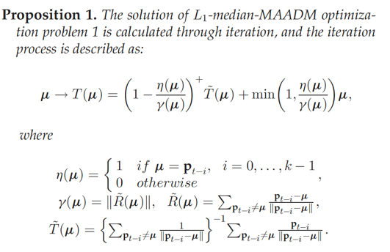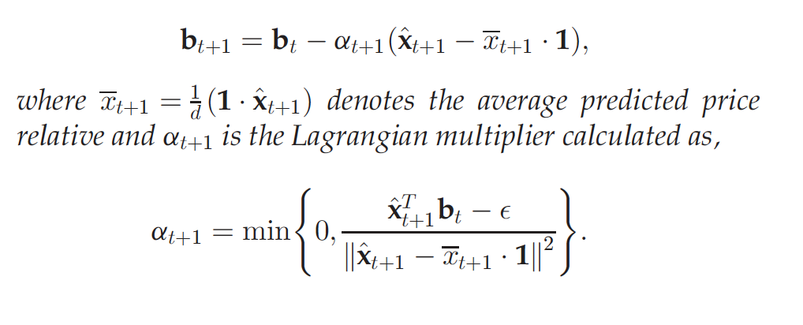

**Invention and other Strategies**

As the 2nd optimization of RMR is simply a regularization for large change which will incur large transaction cost and 1st optimization is about prediction price, it is obvious we can replace Robust $L_{1}$-Median Estimator with **ARIMA** model and form a new strategy to be compared with RMR later. Auto.arima() is used to choose the ARIMA model for asset $i$ at period t, which foreseeably requires large computation.

4 other strategies are compared with RMR later, which is Best-stock (‘BEST’), Passive aggressive mean reversion (‘PAMR’), Online Moving Average Reversion (‘OLMAR’) and Market. They are implemented as R functions.

**Implementation**

We implemented these estimators from function T and Lagrange Multiplier using R and packaged the RMR strategy as function. Users only need to choose $ε$, $ω$ and transaction cost to run the program and obtain the daily return series, terminal wealth. At the same time, indexes which will be introduced are computed.